**Task 3:**

Developing a Linux kernel module involves writing code that can be dynamically loaded into the Linux kernel to extend or modify its behaviour. Here are our steps to develop a Linux kernel module:

1. Install the Linux kernel headers:

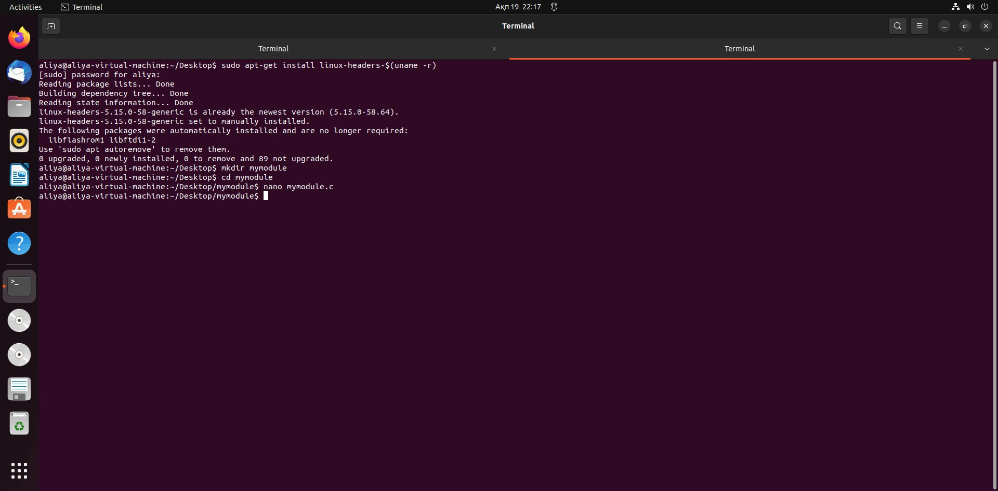

$ sudo apt-get install linux-headers-$(uname -r)

This will install the necessary headers for the kernel version that we are running.

1. Create a new directory for the kernel module:



$ mkdir mymodule

$ cd mymodule

1. Create the kernel module source code file:

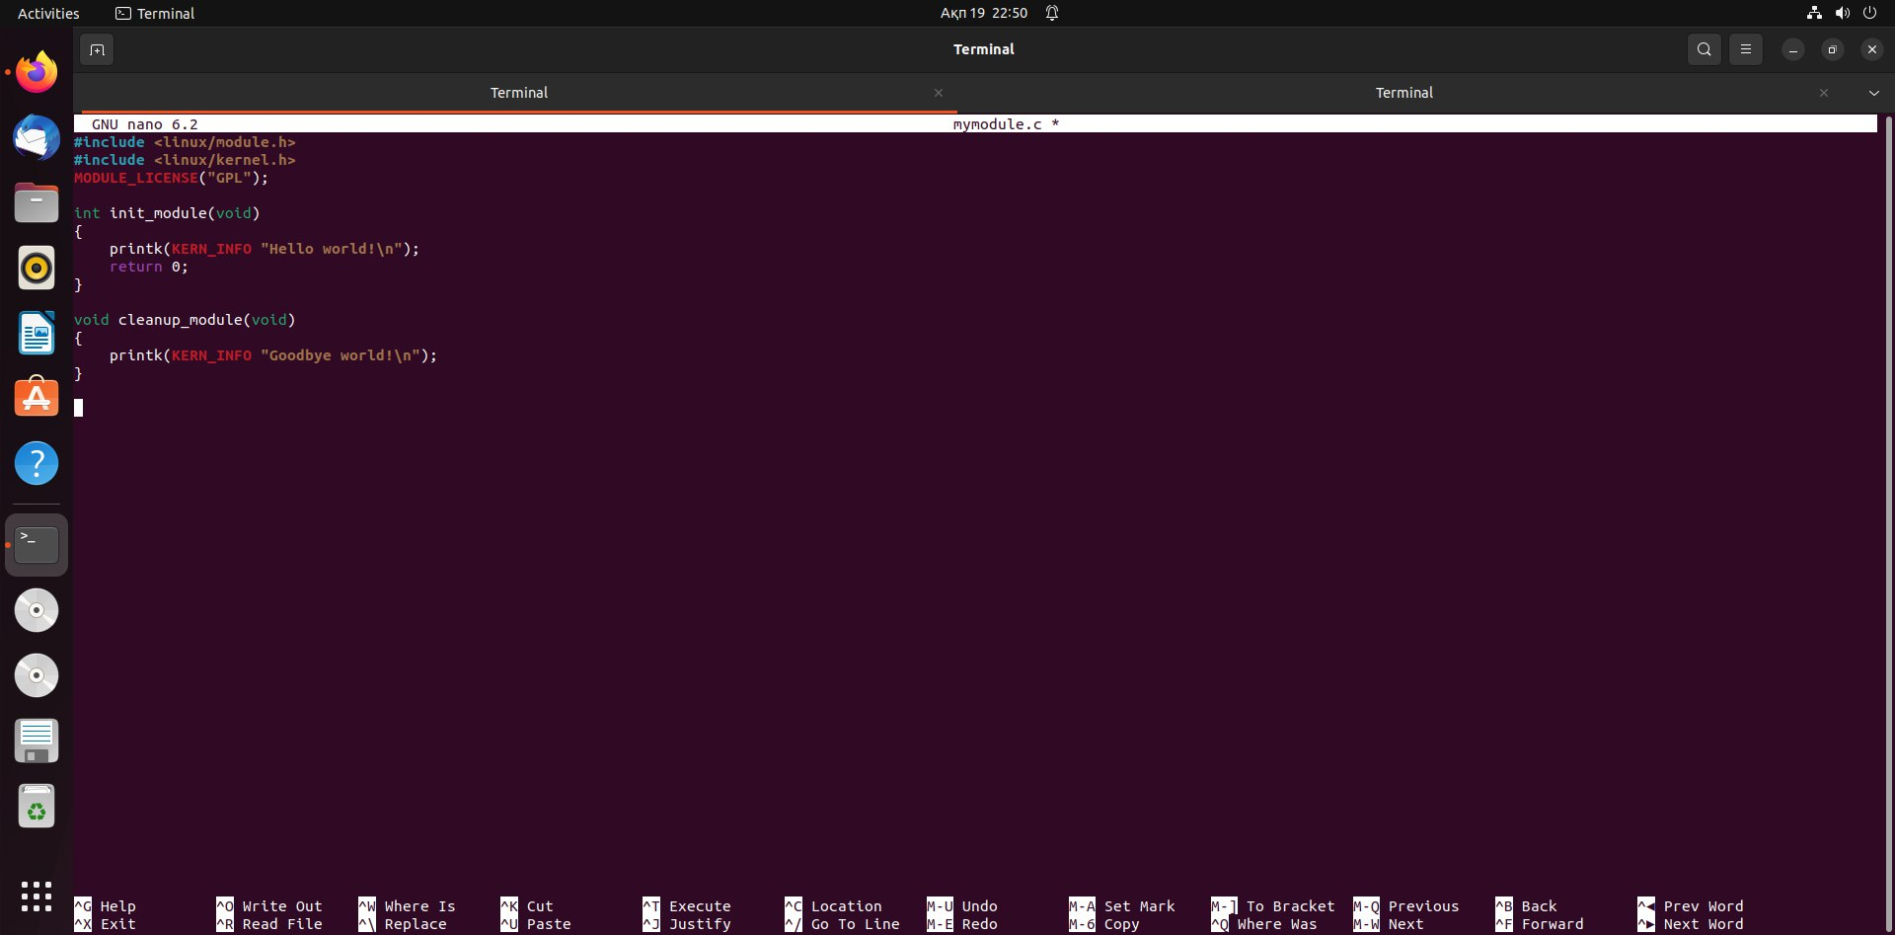

$ nano mymodule.c

#include <linux/module.h>

#include <linux/kernel.h>

int init_module(void)

{

    printk(KERN_INFO "Hello world!\n");

    return 0;

}

void cleanup_module(void)

{

    printk(KERN_INFO "Goodbye world!\n");

}

This code defines two functions, ‘init_module’ and ‘cleanup_module’, which are called when the module is loaded and unloaded, respectively. The ‘printk’ function is used to output messages to the kernel log.

1. Create a Makefile for the kernel module:

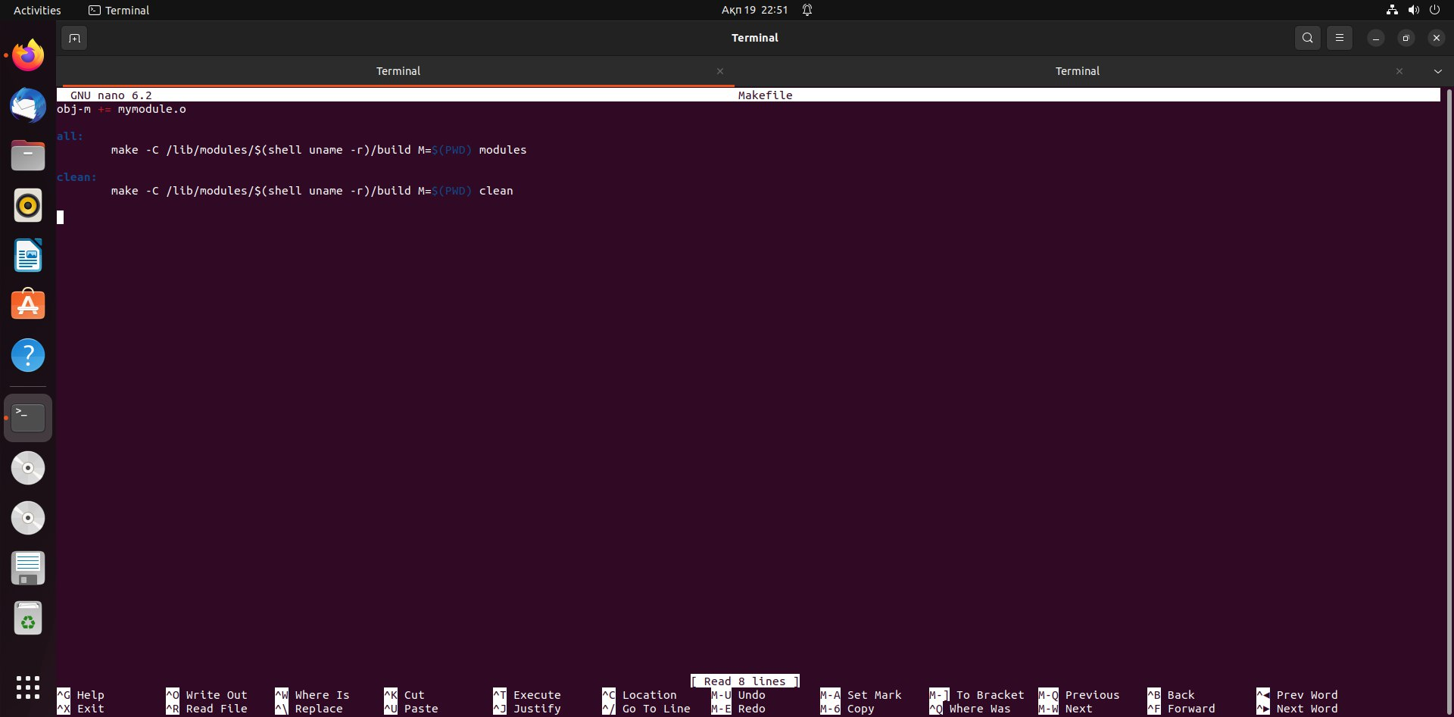

$ nano Makefile

obj-m += mymodule.o

all:

     make -C /lib/modules/$(shell uname -r)/build M=$(PWD) modules

clean:

     make -C /lib/modules/$(shell uname -r)/build M=$(PWD) clean

This Makefile tells the ‘make’ command to build the ‘mymodule’ object file from the ‘mymodule.c’ source file. The ‘all’ target compiles the module, and the clean target removes the compiled files.

1. Build the kernel module:

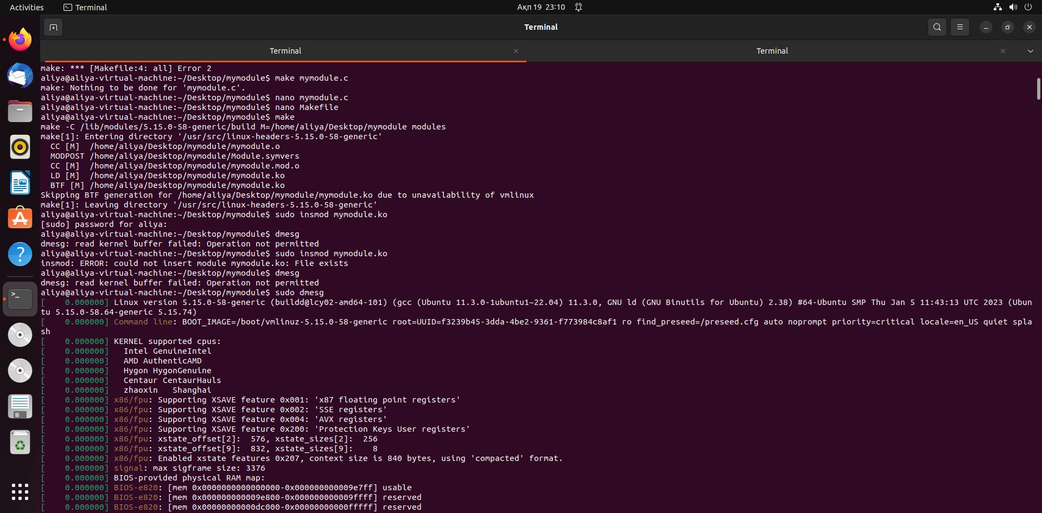

$ make

This will compile the kernel module and generate the ‘mymodule.ko’ file.

1. Load the kernel module:



$ sudo insmod mymodule.ko

This command loads the ‘mymodule’ kernel module into the Linux kernel.

1. Check the kernel log for the output of the module:

$ dmesg



This command displays the kernel log. You should see the "Hello world!" message printed by the kernel module:

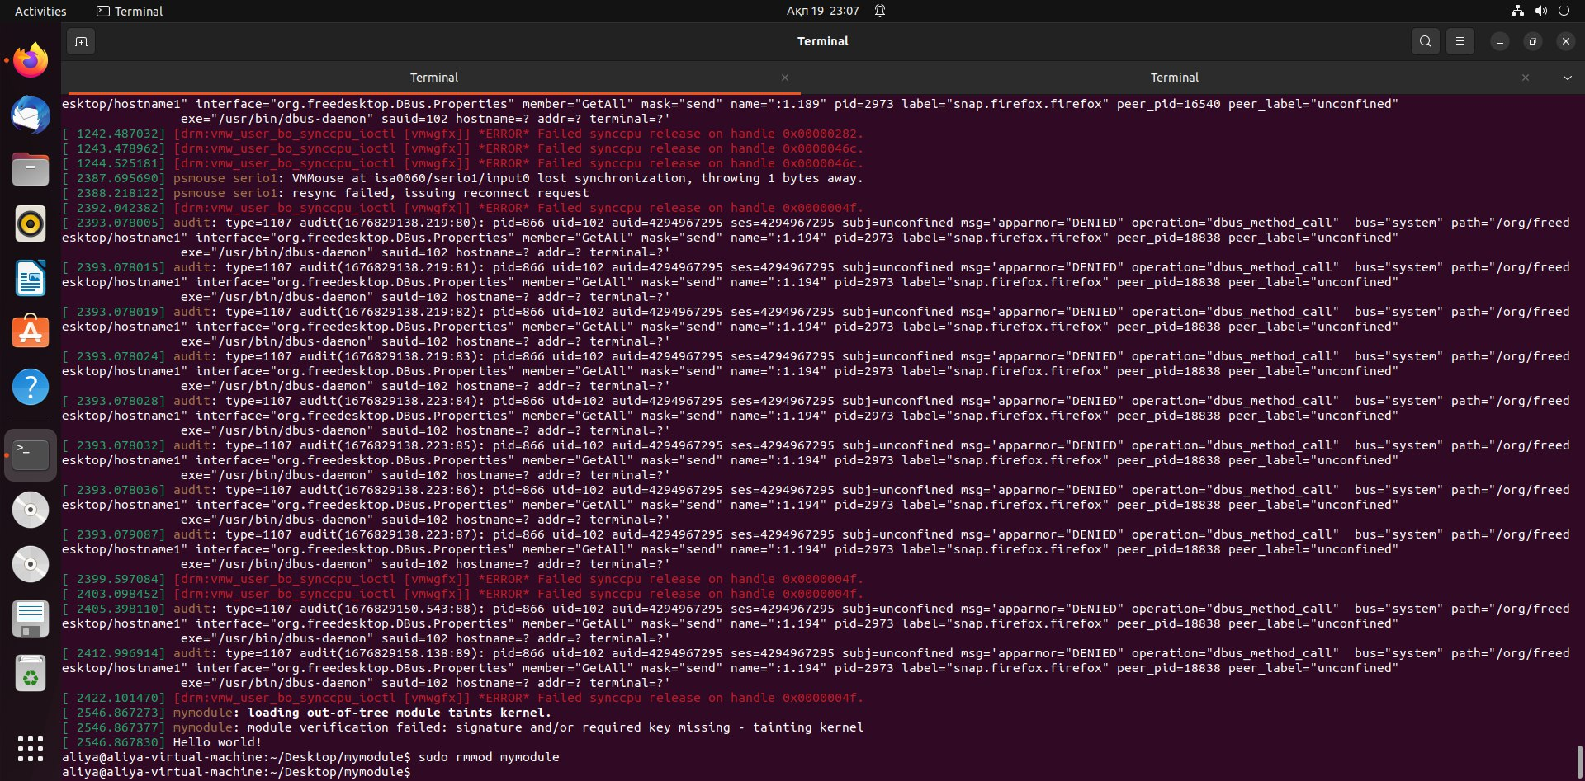



 output: https://www.pastbin.net/untitled-616

1. Unload the kernel module:



$ sudo rmmod mymodule

This command unloads the ‘mymodule’ kernel module from the Linux kernel.